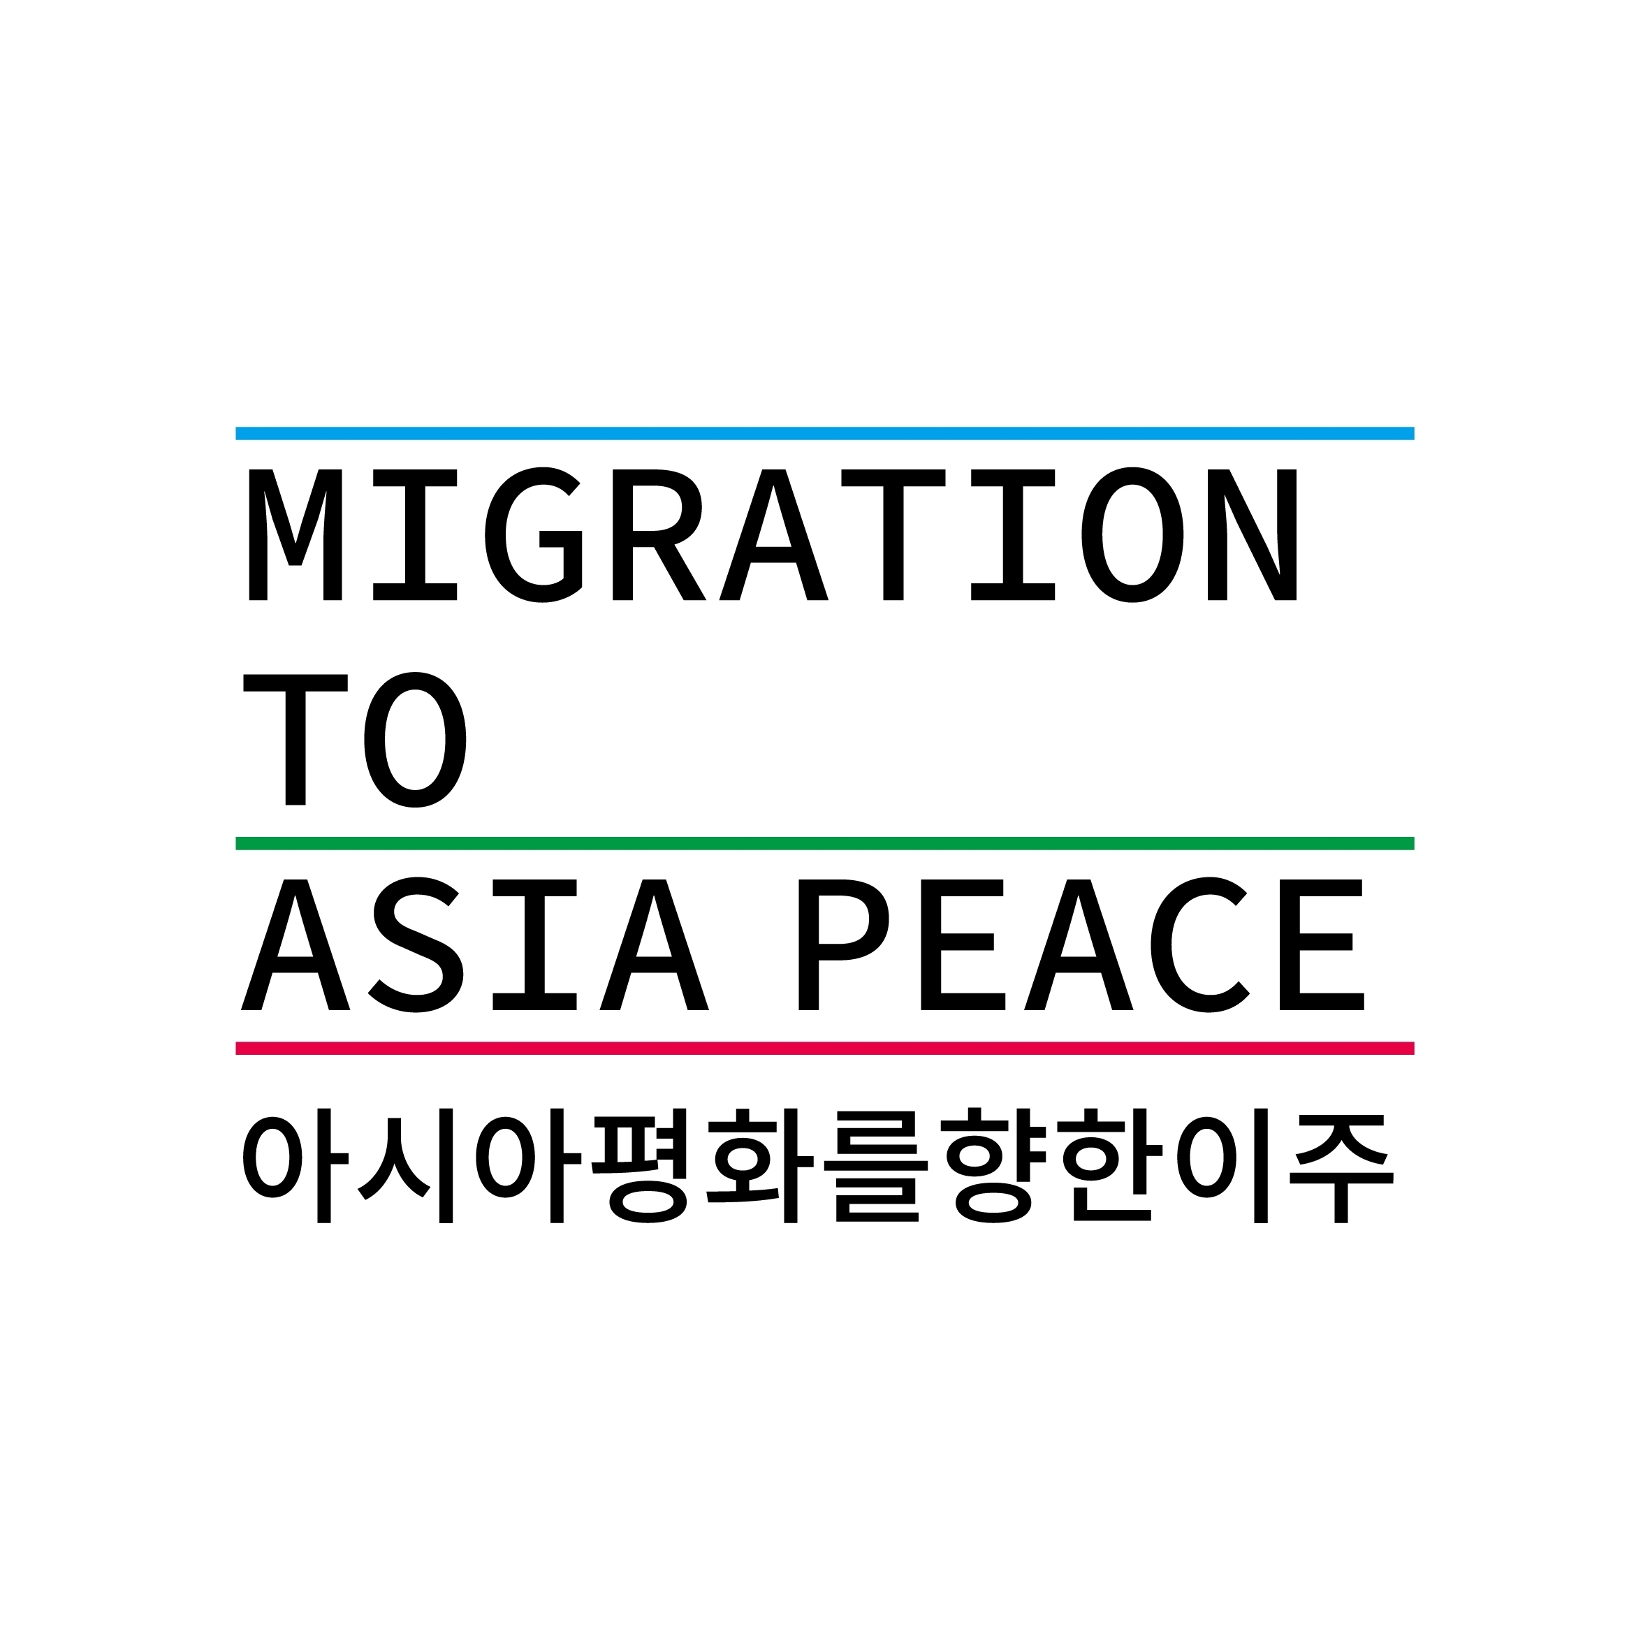

Easy-to-Read Guidelines for Refugees
난민을 위한 읽기 쉬운 정보 제공 길라잡이

Easy-to-read material is important for people with intellectual disabilities, people with low literacy skills, and people for whom the language of the original text is not their first language. Easy-to-read is a global standard that comes under the right to accessible information.

Migration to Asia Peace (MAP) has developed guidelines for making information easy to read and understand for refugees and has begun applying them to Refugee News. We hope the practice of making information more accessible becomes widespread. Then, more refugees can access information, learn new things, and participate in society.

읽기 쉬운 자료는 지적 장애가 있는 사람, 읽기 쓰기 능력이 낮은 사람, 글에 쓰인 언어가 제1 언어가 아닌 사람에게 중요합니다. 읽기 쉽다는 것은 접근할 수 있는 정보에 대한 권리로 국제적 표준입니다.

아시아평화를향한이주(MAP)는 난민이 정보를 쉽게 읽고 이해할 수 있도록 길라잡이를 개발해 ‘난민뉴스’에 적용하기 시작했습니다. 우리는 정보에 대한 접근성을 높이는 실천이 널리 확산하기를 바랍니다. 그러면 더 많은 난민이 정보에 접근하고, 새로운 것을 배우고, 사회에 참여할 수 있게 됩니다.

General Rules
Text Structure and Layout
1. Simple Sentences
- Keep one piece of information or point in each sentence.
- If more information is needed for clarity, please keep the sentences concise.
- Avoid complex sentence structures and break long sentences into shorter ones.
2. Short Paragraphs
- Each paragraph should cover only one topic.
3. Use of Headings
- Create intuitive headings that include the subject and main point.
- Differentiate between headings and subheadings to logically organize information.
- Use subheadings that best describe the content.
4. Text Formatting
- Choose fonts and font sizes considering the age and nationality of the readers.
- Adjust line spacing and provide sufficient margins.
- For languages that use right-to-left scripts, align the text accordingly.
Vocabulary and Grammar
5. 'Easy-to-Understand’ Words
- Avoid complex and technical terms. If difficult terms are necessary, provide explanations.
- Do not use abbreviations unless necessary for context.
- Use the most commonly used words.
- Do not change the terms used in official documents. This will make it easier to find information online or in official documents.
  - Official terms: Work Permit(Engage in Activities not Covered by the Status of Sojourn), Foreign Resident Registration, Immigration Control Act, etc.
  - Document names: Application Form(Report Form),Application for Recognition of Refugee Status, etc.
  - Building names: National Health Insurance Service, Immigration Office, etc.
6. Grammar
- Check spelling and grammar before finalizing any documents.
- Apply the grammatical rules of the respective country.
  - English: Subject-verb agreement, tense consistency, article use, active voice, etc.
  - Korean: Subject-predicate agreement, honorifics, spacing, etc.
- If the text sounds awkward when read aloud, revise it to make it sound natural.

7. Consistent Language and Tone
- Maintain a tone suitable for the nature of each document.
- Use the same word consistently.
Information Layout
8. Clear Information Delivery
- Ensure key information is easy to find and read.
- Provide an overview before starting the main text.
- Arrange information to maintain a logical flow.
- Use bullet points for listing information.
- Provide understandable examples and evidence.
- Use links for external information rather than lengthy explanations.
Diversity
9. Neutral Tone
- Convey information neutrally, without reflecting the information provider's values, nationality, or culture.
  - Use "Korea" instead of "Our country."
10. Respectful Words
- Consider that the same words can be interpreted differently depending on cultural and political backgrounds.
- Use gender-neutral expressions.
11. Audience Inclusiveness
- Provide files with braille or audio for people with visual or hearing impairments.
Images and Symbols
12. Use of Images, Symbols, and Diagrams
- Images and symbols should be clear, unambiguous, and relevant to the text.
Feedback
13. Incorporating Feedback
- Obtain feedback from people with low literacy, intellectual disabilities, or refugees for whom the first language is different.
- Revise the text based on the feedback.
Accessibility
14. Variety in Delivery Methods
- Use various methods to deliver news, such as social media (SNS), websites, and others.
- Select the delivery method based on the purpose of the information.
  - Websites should contain detailed news, while card news should be concise to enhance readability and accessibility.
15. Increasing User Access
- Use suggested keywords in search bars to make searches easier.
- Avoid using words or conjunctions that are unrelated to key terms.
- Standardize the spelling of proper nouns in titles and texts.
  - Different spellings like "Refugee policy", “refugee policy” can confuse searches. Use consistent terms like "refugee policy."
  - If using both Korean and English key terms, standardize them to "난민정책 (Refugee policy)."
- Use hashtags effectively.

Contributors of MAP 1.0
Donggyu Hyunbin Jaeyoung Jooyoun Nagyoung Yehyun Youngah

Reference
https://easy-to-read.eu/european-standards/
https://www.inclusion-europe.eu/easy-to-read-standards-guidelines/
https://buly.kr/7m9UlZG
National Institute for Health and Care Research(NIHR), "A guide to creating inclusive content and language", September 2021

